**YLDP Session with Mayor Annise Parker**

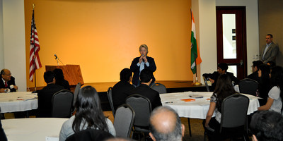

On March 3rd, 2012, Major Annise Parker visited YLDP students at Houston India House, to deliver an inspiring speech on what leadership really meant, and why it was so important. What we got was something slightly different than a speech, but made much more of an impression upon us. Mayor Parker engaged the YLDP students in an interactive discussion, explaining what exactly government does, from the smallest level, the family, to the city level, and how important leaders are in the decisions made. Throughout her visit, she emphasized the difficulty that comes with making those decisions. She gave us a few key qualities a leader absolutely needs. One of the main reasons leaders fail is that they are unable to make decisions since they are afraid of making people unhappy. Decisiveness is a must for any leader. She also stressed listening to the people a leader leads; it’s important to respect the will of the people a leader represents and in government you have to do just that; the most important thing is the greatest amount of good, for the greatest amount of people, for the greatest amount of time. One way we can start a path to leadership is by getting involved in the community. If we do that, it becomes much easier to understand the community, and what they want out of their leaders, and also help builds strong, trusty relationships. Throughout the session students learned that as the youth of our generation, we too could make a difference by volunteering and participating at various events, through which we could advocate and stand up for what we believe in. By taking a stand, we too can make an influence on the decisions made by the elders of the community. By getting our voice across and showing we care for the community, we can become helpful and willful leaders.

YLDP students Anirudh Pillutla, Aditya Srinivasan, Khushi Parihar, Namita Pallod and Shreeya Upadhyay collaborated on this article